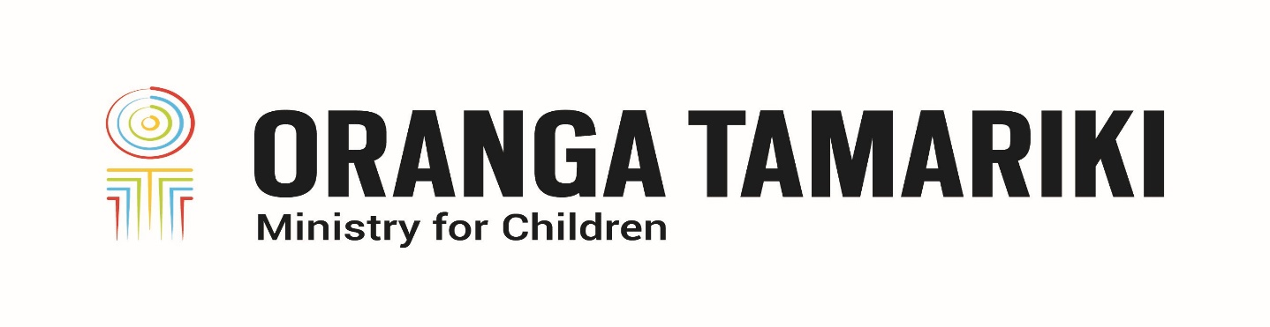
Oranga Tamariki Disability Strategy—How we see disability
Adapted in 2023 by Accessible Formats Service,
Blind Low Vision NZ, Auckland
TN: Logo on the top of the page is: Oranga Tamariki Ministry for Children.

Oranga Tamariki Disability Strategy—How we see disability
To achieve our vision, Oranga Tamariki and our partners have identified four shifts that must occur.

Shift one—How we see disability
Oranga Tamariki takes a whole of life approach to disability, understanding that disability is only one component of who tāngata whaikaha (disabled people) are, and disability can be a collective experience for tāngata whaikaha me o ratou toa (disabled people and their champions).
We need this shift because often, Oranga Tamariki only addresses the immediate situation and sees disability as something to diagnose and fix, rather than identifying and addressing the barriers tāngata whaikaha experience.

Ideas we've heard to achieve the shift
From our engagements and feedback, we have also heard some ideas on how to achieve this shift:
- Resource disabled tamariki (children) and rangatahi (young people) so they can express their views and ensure those views are heard.
- Inform tāngata whaikaha me o ratou toa of their rights and all services available to them.
- Enable all disabled people (including those with non-verbal communication) to participate in all decision-making that affects their lives.
- Increase understanding within Oranga Tamariki that someone's disability can be part of who they are, not just a diagnosis, and their disability is not the only thing that defines them.
- Develop services and resources so disabled tamariki get the same opportunities as their non-disabled peers.
- Review the Oranga Tamariki transition services to ensure they are accessible and inclusive of all rangatahi whaikaha (young disabled people). The review needs to be done in collaboration with other agencies who will be involved in the young person's life.
End of Oranga Tamariki Disability Strategy—How we see disability

